Test Case: tc001_SPX_Dev5_Crear_Solicitud_Articulo_Almacen
Step 1 - Enter username and password and click to button Enter : Credentials Entered
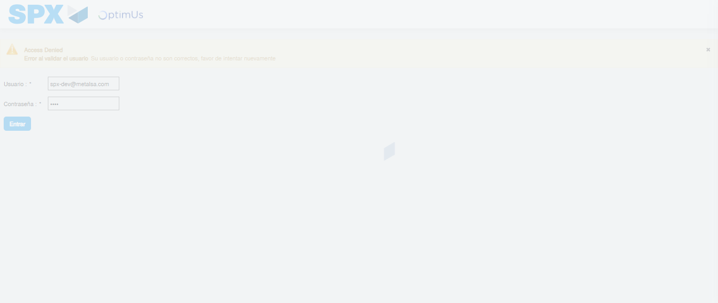Image file-name: QC_Testing-tc001_SPX_Dev5_Crear_Solicitud_Articulo_Almacen-1787839813189

Step 2 - Select to UEN and Access to Request for a New Inventory Item : UEN Correctly selected and Correct access
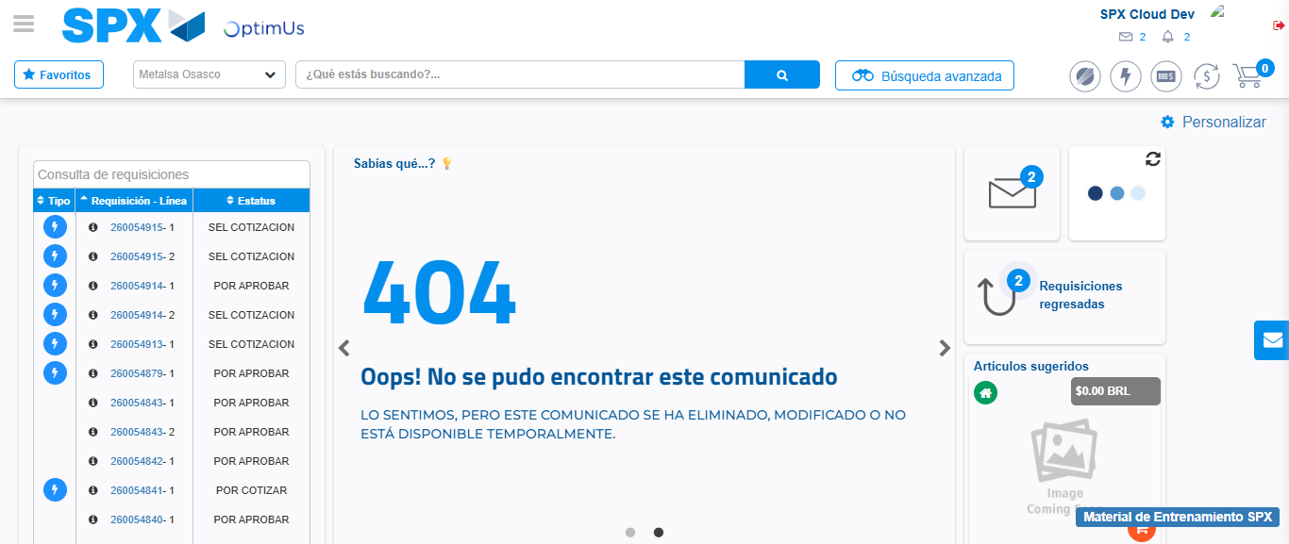Image file-name: QC_Testing-tc001_SPX_Dev5_Crear_Solicitud_Articulo_Almacen-1787839839129

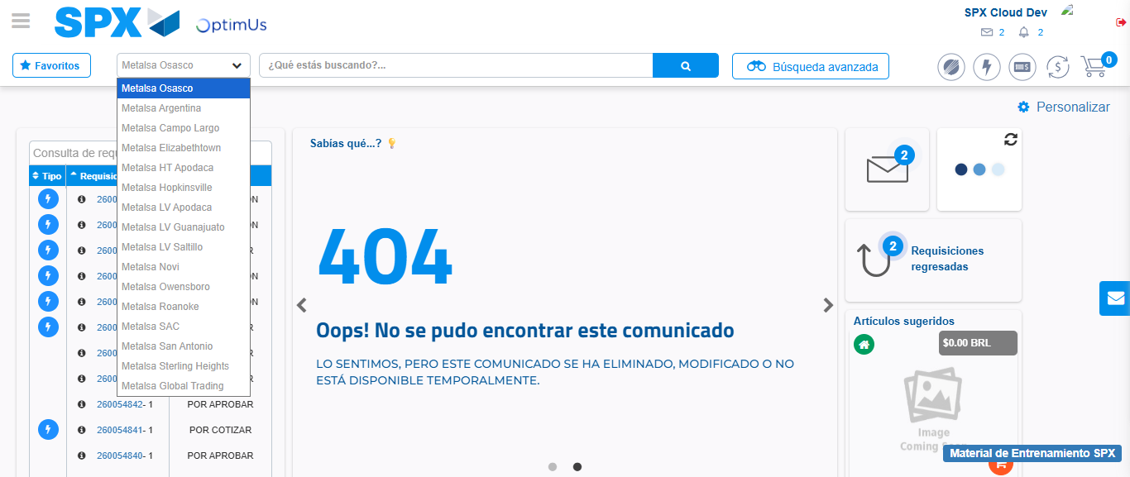Image file-name: QC_Testing-tc001_SPX_Dev5_Crear_Solicitud_Articulo_Almacen-1787839841986

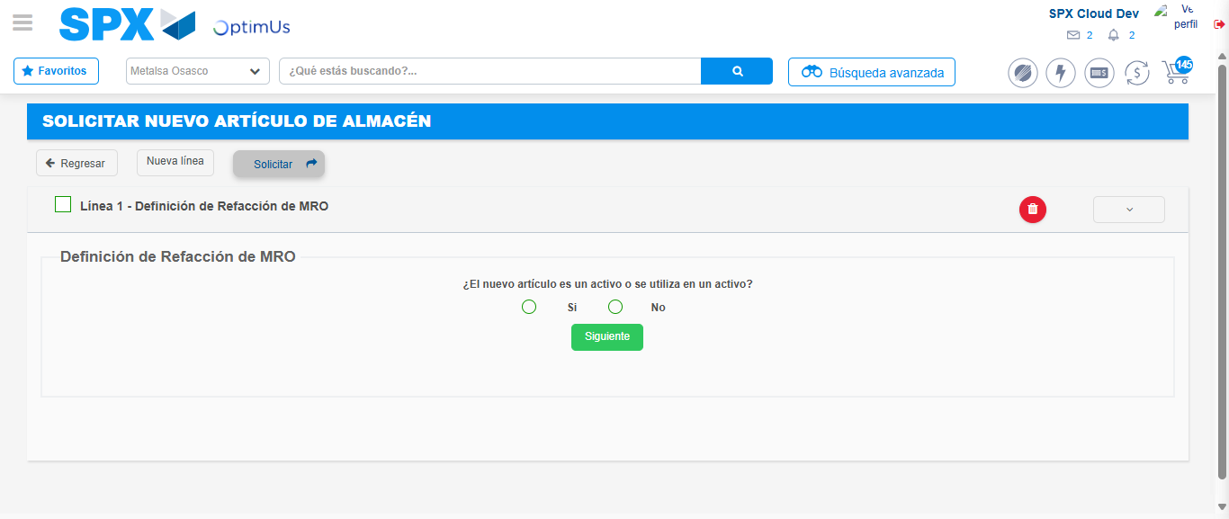Image file-name: QC_Testing-tc001_SPX_Dev5_Crear_Solicitud_Articulo_Almacen-1787839864696

Step 7 - Return to Main Page SPX : Return to Main Page SPX
Image file-name: QC_Testing-tc001_SPX_Dev5_Crear_Solicitud_Articulo_Almacen-1787839839129

Image file-name: QC_Testing-tc001_SPX_Dev5_Crear_Solicitud_Articulo_Almacen-1787839841986

Image file-name: QC_Testing-tc001_SPX_Dev5_Crear_Solicitud_Articulo_Almacen-1787839864696

Image file-name: QC_Testing-tc001_SPX_Dev5_Crear_Solicitud_Articulo_Almacen-1787839867358

Image file-name: QC_Testing-tc001_SPX_Dev5_Crear_Solicitud_Articulo_Almacen-1787839867555

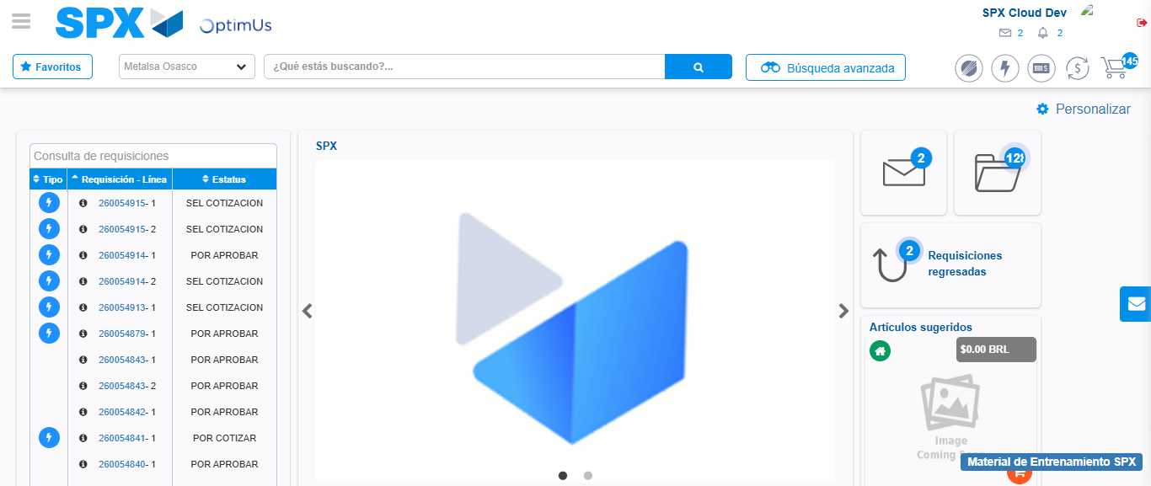Image file-name: QC_Testing-tc001_SPX_Dev5_Crear_Solicitud_Articulo_Almacen-1787839888951

Step 8 - Log Out : Log Out SPX
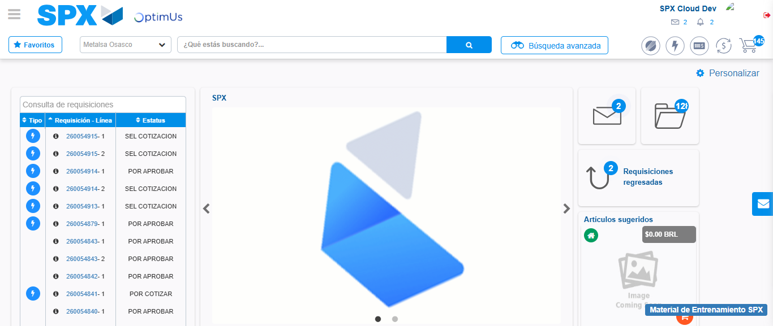Image file-name: QC_Testing-tc001_SPX_Dev5_Crear_Solicitud_Articulo_Almacen-1787839889315

